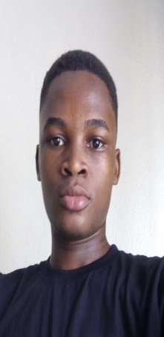

Highly motivated and versatile professional with internship experience in computer science, software engineering, and photography. Possesses strong technical skills in programming, software development, and graphics design. Effective collaborator with excellent communication and teamwork skills. Proficient in managing projects, meeting deadlines, and adapting to evolving requirements. Committed to continuous learning and growth. Detail-oriented and dedicated to delivering high-quality results. Knowledgeable software engineering professional experienced in building scalable and modular software products. Strong interpersonal skills for effective stakeholder collaboration. Meticulous and organized with a track record of meeting tight deadlines. Enthusiastic team player driven to achieve demanding development objectives.

**PROSESSIONAL SUMMARY**

+234 8160828610

olusatimmie07@gmail.com

5, Shifau Crescent, Ikosi-Ketu, Lagos State.







**Timilehin Olusa**

**SKILLS**

* **Software development**
* **Software documentation**
* **Software implementation**
* **Testing and maintenance**
* **Software applications**
* **Website troubleshooting**
* **Workflows and queries**
* **HTML expertise**
* **Database programming**
* **Analytical problem-solver**
* **Meticulous Observer**
* **Adaptive Learner**

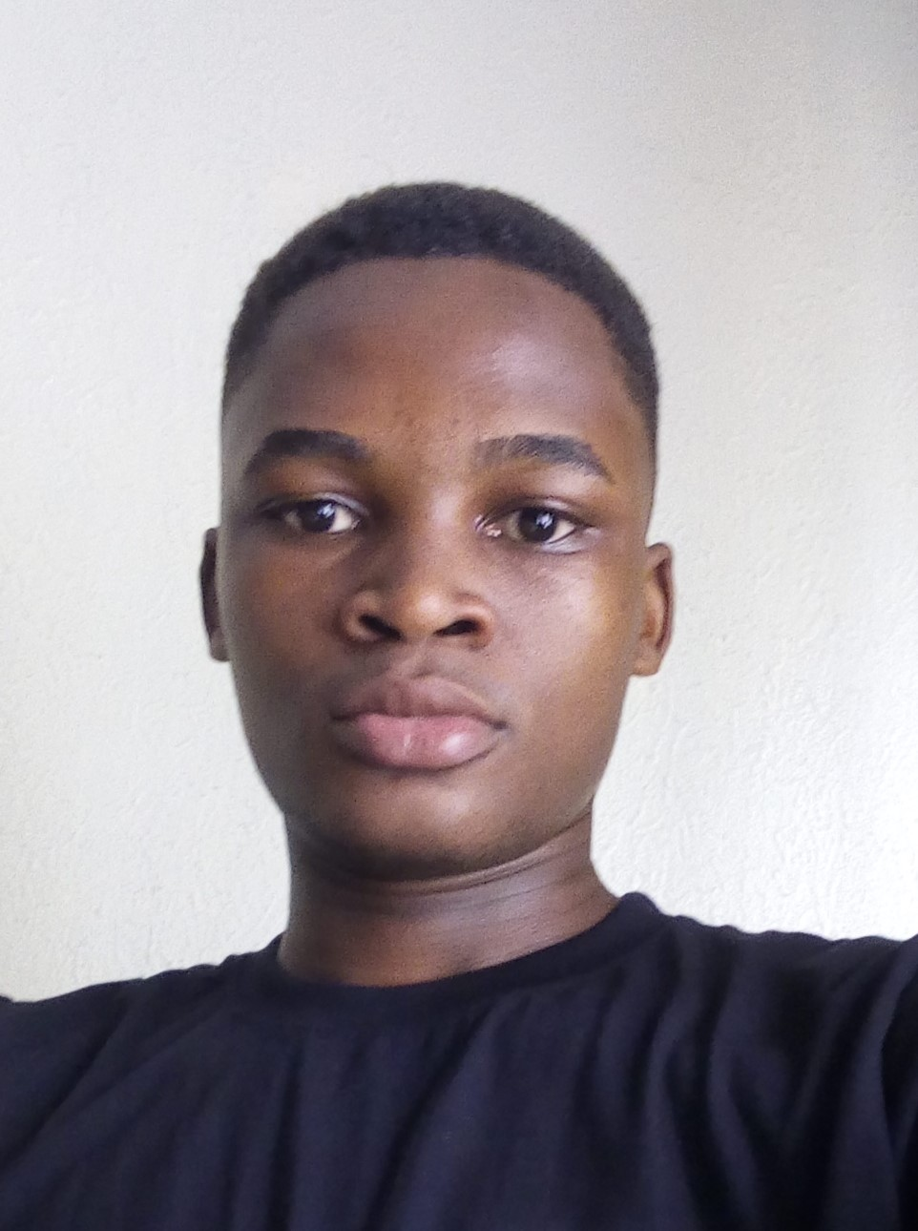

**WORK HISTORY**

**07/2022 – Current**

**Software Engineering**

**ALX | Naiobi, Kenya**

Resposibities

* Collaborate with software development teams for coding, debugging, and testing.
* Participate in designing and implementing software features or components.
* Conduct research on software engineering best practices and technologies.
* Support maintenance and enhancement of existing software systems.
* Contribute insights and ideas in project meetings.
* Document code, processes, and project progress.

Achievements

* Develop and implement software features or modules.
* Resolve software issues and bugs.
* Successfully complete projects within deadlines.
* Gain practical experience in programming languages, frameworks, and tools.
* Demonstrate problem-solving skills through innovative solutions.
* Receive positive feedback for work quality and professionalism.

**Programming Languages**

* **Python**
* **Java script**
* **C**
* **HTML, CSS**

**Programming Tools**

* **Python**
* **Flask**
* **MySQL DB**
* **Postgresql DB**
* **SQLite**
* **HAProxy**
* **NGinx**
* **Jquery**

**Design Tools**

* **Figma**
* **Photoshop**
* **Adobe Illustrator**



Job Details

* Learning Opportunities: Work closely with experienced software engineers, receive mentorship, and attend training sessions.
* Collaboration: Collaborate with software development teams, including engineers, designers, and project managers.
* Exposure to Technologies: Gain exposure to various programming languages, frameworks, and tools.
* Performance Evaluation: Receive periodic performance evaluations and feedback.
* Networking: Build professional connections within the organization.

**03/2021 – 10/2021**

**Computer Science Intern**

**Classic Info System | Osun, Nigeria**

Responsibilities

* Assist with software development tasks, collaborate with team members, and conduct research.
* Support the maintenance and enhancement of software systems.
* Participate in meetings, contribute ideas, and document project progress.

Achievement

* Develop and implement new software features.
* Contribute to resolving software issues and bugs.
* Successfully complete assigned projects on time.
* Gain practical experience in programming languages and frameworks.
* Demonstrate problem-solving skills and receive positive feedback for work quality.

Job Details

* Collaborate with software developers, engineers, and project managers on ongoing projects.
* Gain exposure to various programming languages, frameworks, and tools.

**04/2018 – 01/2021**

**Photography Intern**

**Dhan Photography Studio | Lagos, Nigeria**

Job details

* Learning Opportunities: Work closely with experienced photographers, receive mentorship, and attend photography-related training or workshops
* Collaboration: Collaborate with the photography team, including photographers, art directors, and clients.
* Master Design tools like Photoshop, Figma, Adobe Illustrator

**EDUCATION**

**02/2017 – 10/2021**

**Faith Standard Cephalo College | Nigeria, Osun**

**GCSEs: Science and Technology - With honours**

**08/2023 – Curreent**

**Federal University of Technology Akure | Nigeria, Akure**

**Bachelor of Science: Computer Science**

**LANGUAGES**

**English:**

**Fluent**

**REFEREE**

**Name : Monsurat Olooto**

**Job Title : Retailer**

**Company Name : Bumsayo Enterprises**

**Phone Number : +2348033160133**